

\***Crimes Committed:** Threated Native Fish and Wildlife resources. Taken over ecosystems. Killed many native species.

**\*Reward:** A better ecosystem, and a Snakeheaed fish for dinner.

Suspected Hideouts: Along East Coast.

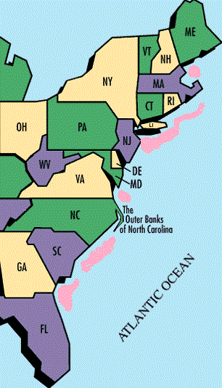

**\*Last Seen**: (Orininally) Asia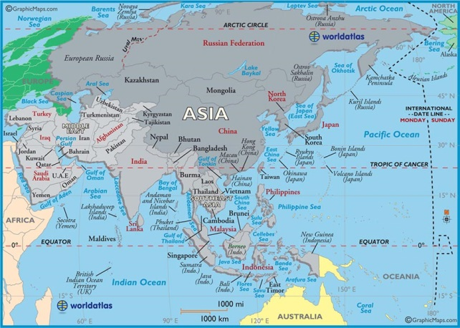

**WANTED NAME**: Black Eyed Jim

**Common Name**: Snake Headed Fish

**Scientific Name**:Channa Striata

**Identifying Characteristics:** Aggressive, 4 feet*,*

large mouth with a strong jaw and sharp, canine-like teeth. Its head resembles that of a snake

**Where From:** North, East Coast, and Asia.

DEAD OR ALIVE!

WANTED!

